创造更多可能 Create More Possible
For more information can visit our official website：www.feiyu-tech.com
Technical support e-mail：uavservice@feiyu-tech.com
Some functions may have change due to product firmware updates and changes.
Users can get the latest instructions from the official website. Integrated Digital Radio
Quick Start Guide

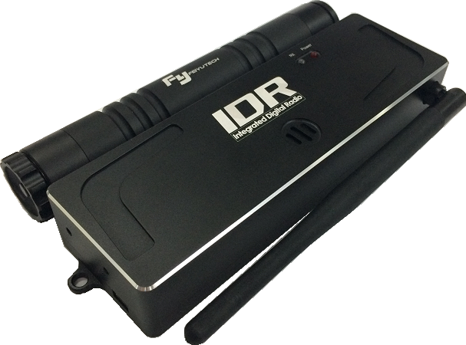

Dear customers,
Thank you for purchasing and using Feiyu Tech’s product . For you can use this product better，Please read this
Quick Start Guide before using this product.

Advantage
● Integrated Digital Radio can install the remote-control receiver . It can upload the remote-control receiver's signal and GCS's signal to autopilot , and it also can receive the flight parameters from the autopilot automatically.
● Integrated Digital Radio integrates the most advanced station , it uses the Frequency Hopping Spread Spectrum (FHSS) . This will guarantee the anti-interference ability and inform security.
● Integrated Digital Radio can connect with computer by using USB line or Bluetooth.
● Only need to install two 18650 batteries .

Attention
● Do not use data radio in an operating environment beyond its environmental characteristics.
● Do not touch the antenna when using the data radio.
● The remote-control receiver needs to be purchased separately.
● Erect the antenna vertically when using.
● Two connection modes cannot be used at the same time.

Disclaimer
● Prohibit any user for any illegal purpose . Users will be responsible for all behaviors of purchase and use products.
● Our company assumes no liability for any risks related to or resulting from the debug and use of this product
(Including the direct , indirect or third-party losses ).
● For any unknown sources of using , we will not be at any services.
● The updating and changes of product firmware and program may cause changes in function descriptions in this
user manual , please read the instructions carefully before upgrading the firmware and use the corresponding
user manual.
● You can get the latest user manual from the official website : www.feiyu-tech.com
● Feiyu Tech reserves the right to amend this manual and the terms and conditions of use the product at any time.
● This Agreement comes into effect automatically when the user purchases the product

S1 Product SummaryS

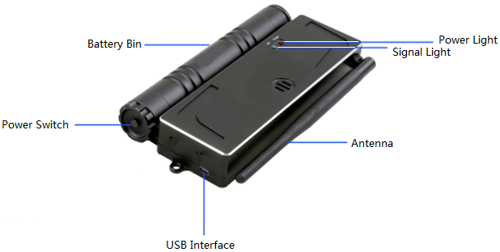

S2 Remote-Control Receiver Installation InstructionS

- Disassembly the Integrated Digital Radio’s antenna first.

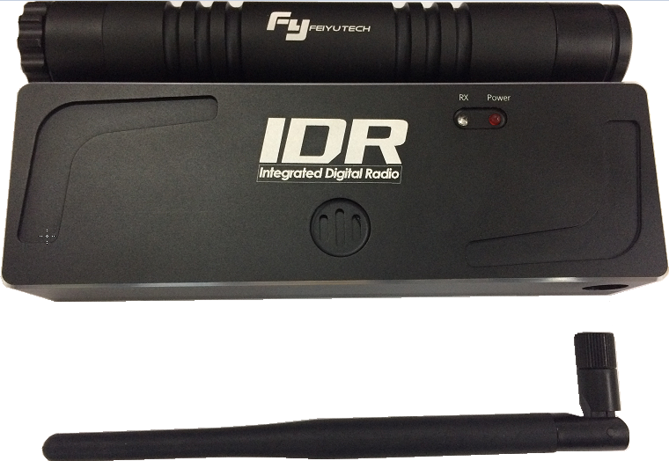
- Unscrew the back screws.（Screw Specification : M2*12）
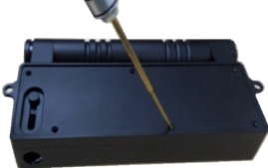
- Disassembly the top cover.
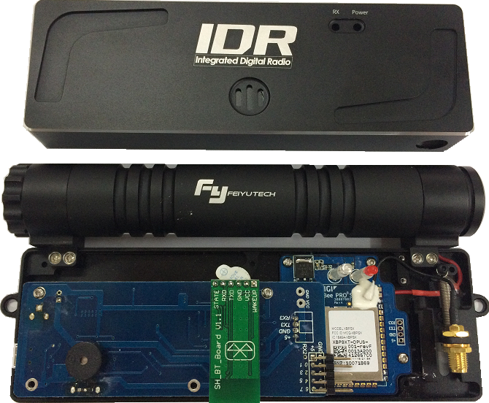
- Using the 2*5P RC Receiver connection line to connect the Integrated Digital Radio and Remote-Control Receiver .
And using 3M double faced adhesive tape to glued it on circuit board.
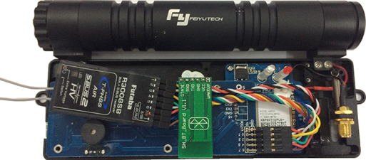
- Placing two antennas of the Remote-Control Receiver through the top cover’s antenna hole.
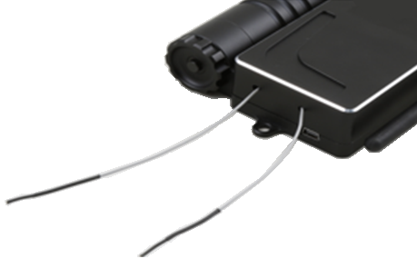
- Assembly the top cover and screws and install the battery .（The battery anode is positioned in the battery bin）
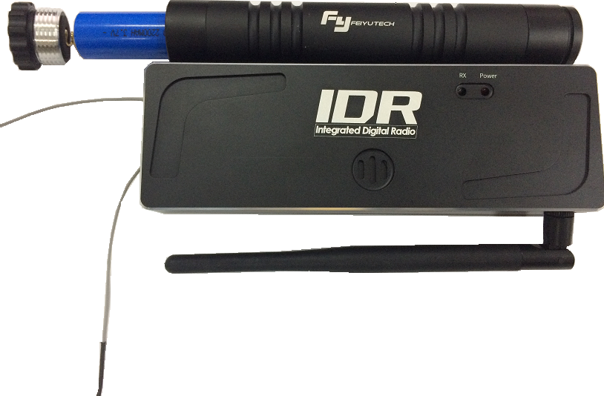
- After install the Remote-Control Receiver , turn on the power and you will heard prompt tone . It will tell you the
voltage status of the battery.

SAttentionS

- The following form is the instruction of the interface of Integrated Digital Radio and remote control
Receiver:

Mark | Port Function
GND | Ground lead
+5 | Provide +5V Output to the receiver
RX2 | Reserved Port
0 | Aileron input
1 | Elevon input
2 | Throttle input
3 | Rudder input
4 | Channel 5 input
5 | Channel 6 input
6 | Channel 7 input
7 | Channel 8 input

- The following form is the instruction of prompt tone function:

是Prompt tone | 是Instruction
Three Times | The battery voltage is above 8V，the power is enough.
Twice | The battery voltage is between 7.6V~8V，the power is medium
Once | The battery voltage is between 7.2V~7.6V，the power is low
Constantly | The battery voltage is below 7.2V，needs to be charged

S3 Connect IDR with GCS and AutopilotS

There are two kinds of connection methods for Integrated Digital Radio to connect with GCS：
- Using USB line.
- Using Bluetooth.

SISSUsing USB line

- Download the USB drive from the www.feiyu-tech.com and install it.
- Turn on the Integrated Digital Radio , then use USB line to connect Integrated Digital Radio with computer . And then you can find “ Silicon Labs CP210 x USB to UART Bridge (COM 4) ” in the Device Manager.
- Open the GCS 5.24 , and select the COM port and Baud rate in “ Control “ , then input the default password “00000” and click “OK” . Finally , input your flight log’s name and save it .
- Turn on the planes power , then the autopilot will connect with Integrated Digital Radio automatically . And you will see the parameters send from autopilot in GCS 5.24.
- After using , please turn off the device’s power as the following order : Turn off the plane’s power → Click “Disconnect” in “Control” in GCS 5.24 → Close GCS 5.24 → Turn off the Integrated Digital Radio → Remove the USB line.

SIISSUsing Bluetooth
- Make sure that your computer has the Bluetooth module and it can work normally before using this method.
- Turn on the Integrated Digital Radio.
- Turn on the computer and right click on the Bluetooth icon and choose “Add device” in the lower right hand corner of the taskbar.
- After the system finds ‘’FeiYu-GCS” , then right click it and input the password ”1234” .
- You can find the COM port in the “Device Manager”.
- Open the GCS 5.24 , and select the COM port and Baud rate in “ Control “ , then input the default password “00000” and click “OK” . Finally , input your flight log’s name and save it .
- Turn on the planes power , then the autopilot will connect with Integrated Digital Radio automatically . And you will see the parameters send from autopilot in GCS 5.24.
- After using , please turn off the device’s power as the following order : Turn off the plane’s power →
Click “Disconnect” in “Control” in GCS 5.24 → Close GCS 5.24 → Turn off the Integrated Digital Radio.
SAttentionS
- The COM port of Integrated Digital Radio is 1~20 . If you find your Integrated Digital Radio COM port not in this
range , please change it.
- IDR can connect with other versions of GCS.
- The default connection password is “00000” , you can change it to what you want.

SAppendix Product ListS

是Item | 数Amount | 是Item | 数Amount
是Integrated Digital Radio | 是1 | 是USB Line | 是1
是18650 Battery | 是2 | 是3M double faced adhesive tape | 是1
是Charger | 是1 | 是 2*5P RC Receiver Line | 是 1

